**Requirement Analysis Document**

**Use Cases**

**Repo Link: https://github.com/Alcks1/CS3704.git**

Gerald Akalugwu (Harvesting and Harvest Management)

Case 1: Crop Yield Prediction

**Primary** **Actor**: Farmer

**Stakeholders** & **Interests**: Farmer, Farm owner, customers, the government

**Preconditions**:

* Data for that crop during that period has to already exist in the system
* Employee/user is authenticated

**Success** **Guarantee**:

Crop yield is generated. Session is recorded.

**Main** **Success** **Scenario**:

1. User arrives with a crop with a barcode on it.
2. User starts a new session with system
3. User inputs the crop in concern, number of seeds, and the time period in question.
4. System records user input. A yield percentage is generated based on user input and previously stored data about the crop.
5. System presents yield percentage to user.
6. System logs session

**Extensions**:

2a. Crop never existed on farm

1. System signals this exception to user

2b. No previous data about crop is stored

1. System signals insufficient data to user

2c. Invalid crop identifier (e.g., broken code, wrong identifier code)

1. System signals error to user

**Special** **Requirements**:

* Robustly recovers systems when access to DB data fails
* System pulls data, draws graph, and calculates percentage within 5 seconds.
* Simple UI to allow users operate more efficiently.
* Speech recognition allows for disabled farmers

**Technology** **and** **Data** **Varation** **List**:

3a. Crop item identifier is entered using a scanner, keyboard, or speech recognition

4a. Yield percentage shown only or a graph of crop performance can be included optionally

Case 2: Crop Inventory management

**Primary** **Actor**: Farmer

**Stakeholders** & **Interests**: Farmer, Farm owner, customers, the government

**Preconditions**:

* Data for that crop during that period has to already exist in the system
* Employee/user is authenticated

**Success** **Guarantee**: Returns whether or not a crop is in stock

**Main** **Success** **Scenario**:

1. User starts a new session with system
2. User inputs the crop in concern.
3. System records user input and inform user whether item is in stock.
4. System asks user if they want the inventory record for that item.
5. User selects ‘YES’
6. Based on input, system searches for data.
7. System presents presents amount in stock, amount expected to be harvested within a certain time period, current demand for crop, and current average market unit price of crop.

**Extensions**:

3a. Crop is not available in stock

1. System informs user

5a. User Selects ‘NO’

**Special** **Requirements**:

* System check database for data within 3 seconds
* Robustly recovers systems when access to DB data fails
* Quickly checks demand for crop and average market price online within 5 seconds.
* Simple UI to allow users operate more efficiently.
* Speech recognition allows for disabled farmers

**Technology** **and** **Data** **Varation** **List**:

2a. Crop identifier is entered using a scanner, keyboard, or speech recognition

Case 3: Auto Harvesting - autonomous farming

**Primary** **Actor**: Farmer

**Stakeholders** & **Interests**: Farmer, Farm owner

**Preconditions**:

* Data for that crop during that period has to already exist in the system
* Employee/user is authenticated

**Success** **Guarantee**: Checks crop harvest status, Harvests crops, Alerts farmers of harvest tasks

**Main** **Success** **Scenario**:

1. User starts a new session with system
2. User selects check harvest status
3. User selects crop to check
4. System uses sensors and cameras to determine crop harvest readiness.
5. System informs user that crop is ready for harvest with an approximation of how many fruits to be harvested.
6. Systems asks user whether to alert farmers for task scheduling purposes
7. User selects ‘NO’
8. System logs session

**Extensions**:

2a. User selects harvest

1a. Selected crop to harvest is unavailable

1. System informs user

1b. User selects crop to harvest

2. System uses sensors and cameras to determine crop harvest readiness.

3a. Selected crop to harvest is not ready for harvest

1. System informs user

3b. System turns on auto-harvester

1. System stops autoharvester when signaled.
2. System informs user how many fruits were harvested.
3. System alerts farmers for task scheduling purposes
4. System updates database accordingly and logs session

2b. User selects check crop harvest status

1a. System alerts user crop is unavailable for harvest

1b. System alerts user crop is not ready for harvest

**Special** **Requirements**:

* System updates database with data within 3 seconds
* Robustly recovers systems when access to DB data fails
* Quickly notify farmers within 5 seconds after harvesting
* Sensors and cameras take within 10 seconds to check harvest readiness
* Automatically schedules another task if harvester is in use

**Technology** **and** **Data** **Varation** **List**:

3a. Crop identifier is entered using a scanner, keyboard, or speech recognition

5a. Crops could either be autoharvested or scheduled for harvest by farmers

Case 4: Crop Rotation Scheduling

**Primary** **Actor**: Farmer

**Stakeholders** & **Interests**: Farmer, Farm owner, customers, the government

**Preconditions**:

* Employee/user is authenticated

**Success** **Guarantee**:

* Crop rotation is scheduled

**Main** **Success** **Scenario**:

1. User starts a new session with system
2. User inputs the crop to rotate/plant next.
3. System check DB for data on that crop.
4. System shows user inventory information about the crop (amount harvested, amount planting)
5. System asks user if they want a planting schedule draft for the crop
6. User selects ‘YES’
7. System uses sensors and data to check soil availability(time till available), soil status(nutrients lacking/in excess), previous crop planted on soil, tools and labor needed to harvest, and approximate amount of fertlizer and water needed for plant.
8. System presents data to user.
9. System logs session

**Extensions**:

4a. No existing inventory data on crop

6a. User selects ‘NO’

**Special** **Requirements**:

* Robustly recovers systems when access to DB data fails
* Simple UI to allow users operate more efficiently.
* Speech recognition allows for disabled farmers
* System pulls data from DB within 5 seconds.

**Technology** **and** **Data** **Varation** **List**:

2a. Crop identifier is entered using a scanner, keyboard, or speech recognition

8a. Data could be presented as a software copy or printed out.

Alex La - External Factors (pest/predator prevention and management, disease protection, natural disaster response)

Case 1: Pest and predator management (Reactive)

**Primary Actor**: Farmer

**Stakeholders & Interests:** Farmers want to keep crops and livestock plentiful. Grocery store management wants to buy the best looking produce to sell to customers. Customers want to buy the good looking produce to eat

**Preconditions:**

**Success Guarantees:** Crops are healthy and plentiful. Users are notified of potential harmful creatures. System informs users of potential reactive solutions. Livestock is healthy and plentiful.

**Main Success Scenario:**

1. Farmer plants a set of crops
2. These set of crops start attracting some new species of animals and insects
3. The system begins to detect some changes to the environment that indicates that new pests might be active
4. The system informs the farmer of the potential problem as well as provide some potential solutions, such as the use of pesticide
5. The farmer takes into account the system’s advice, and uses the specific pesticide
6. The solutions take care of the pests, and the crops are healthy as a result of it.

**Extensions:**

1a. Rather than the farmer planting a set of crops, the farmer now deals with his herd of livestock

1. The farmer introduces a new herd of livestock to a portion of the farm.
2. New predators are attracted to the herd
3. The predators kill some of the livestock
4. The system informs the user of the predators and potential solutions, such as moving the herd to a new place not accessible by predators
5. The farmer takes into account the advice and moves them
6. The herd lives and the farmer is able to get the most out of the herd

3a. The “pest” that the system detected is neither harmful nor beneficial to the farm

1a. The farmer realizes that this pest has no effect on the overall farm

1. The farmer chooses to not implement the recommended solution
2. The farm continues on as normal, and the crops are healthy.

1b. The farmer doesn’t realize that pest has no effect on the overall farm

1. The farmer chooses to implement the recommended solution
2. Since the animal has no effect on the crops, nothing happens. The farm continues as normal and the crop harvest is great

3b. The detected “pest” was actually beneficial to the system

1a. The farmer doesn’t realize that the pest was beneficial

1. The farmer chooses to implement the recommended solution
2. The “pest” is eliminated
3. Without this beneficial animal, other/new pests run rampant
4. The system detects these new pests and repeat starting from step 3

1b. The farmer realizes that the pest is beneficial

1. The farmer doesn’t implement the solution
2. The farm continues as normal and crops are healthy

4a. The “solution” provided by the system was incorrect

1. The pest is still active and harms the crops
2. The farmer realizes too late that the “solution” was incorrect
3. The harvest of the crops is lower than usual, and the farmer doesn’t have much to send to wholesalers for this period of time.

**Special Requirements:** The pest management system has to be up 95% of the time to be able to detect pests and has to have 95% of pests in their database (since this is the second line of defense in the case that the preventative measures fail (use case 2))

**Technology and Data Variations List:**

2/1a: The use of sensors and cameras are able to detect pests/predators.

4: The solution may involve the use of other technologies that are related to the system, a database is needed to store information

Case 2: Pest and predator prevention (Proactive)

**Primary Actor**: Farmer

**Stakeholders & Interests:** Farmers want to keep crops and livestock plentiful. Grocery store management wants to buy the best looking produce to sell to customers. Customers want to buy the good looking produce to eat

**Preconditions:** The prevention system is correctly connected to other systems around the farm

**Success Guarantees:** Crops are healthy and plentiful. Users are notified of potential harmful creatures. System informs users of potential proactive solutions. Livestock is healthy and plentiful.

**Main Success Scenario:**

1. Farmer enters the crop that they are planning to grow into the system
2. The system recognizes the crop and outputs certain information regarding the crop
3. Some information of the crops include how to prevent pests from actively destroying the crops, such as introducing new animals to deal with the potential pests
4. The user takes into account this information and implements it
5. The crops grow perfectly fine without there being any signs of pests.

**Extensions:**

1a. Rather than enter crops, the farmers is now dealing with livestock

1. The farmer enters some livestock that he or she wants to introduce into the farm.
2. The system recognizes the livestock and outputs information
3. Part of that information is dealing potential predators and some countermeasures
4. The farmer introduces the solution, such as a electrified gate
5. Before the predators can do any damage, they are deterred by the electrified gate
6. The livestock are healthy and they all live

2a. The system doesn’t recognize the crop

1. The farmer is able to add their own information to the system
2. The information is specific to one user (users from other farms can’t see this information, so if there is anything wrong with the information it is contained)
3. The next time the farmer decides to plant this crop, they are able to use the system and pull up their own information to create prevention plans

3a. The system provides incorrect information regarding prevention tasks

1a. The user recognizes the information is wrong

1. The user does his or her own preventive measures, without following the system
2. If the user wants to fix this change, they can edit their own system. However, for changes to the system that all users are able to see, this individual needs to send in a support ticket

1b. The user does not recognize that the information is wrong

1. The user follows the system’s recommendations
2. Nothing is prevented, and pests are now being introduced into the system
3. Now this scenario is similar (if not identical) to the first use case scenario (pest and predator management) and would continue from there

**Special Requirements:** The system has to be able to recognize 90% of crops to allow users to receive information and solutions. The system has to be able to be edited on an individual basis, as there might be farm-specific preventative measures that the entire farm needs to be informed of (in case there is a new hire, they follow the farm’s rules, not the general rules).

**Technology and Data Variations List:**

1a. The system must be able to communicate with external technologies, such as an electrified gate

2. Database is used to store general information that is available to all users

Case 3: Disease protection

**Primary Actor**: Farmer

**Stakeholders & Interests:** Farmers want to keep crops and livestock plentiful.

**Preconditions:**

**Success Guarantees:**  Crops and livestock are healthy and plentiful. Users are notified of disease outbreaks and prevention techniques

**Main Success Scenario:**

1. The farmer is preparing to plant new crops
2. The system informs the user of disease preventing techniques
3. The user changes the farm to accommodate these techniques, such as changing the irrigation system
4. After completing these techniques, the farmer begins to plant the new crops, and continues on from case 2 (pest/predator prevention)

**Extensions:**

1a. Rather than preparing to plant new crops, the farmer is preparing to add more livestock

1. The farmer plans to add new livestock to the farm
2. The system analyzes the living conditions of existing livestock
3. The system recommends a way to integrate the new livestock to the existing livestock, whether that be just adding them to the existing herd, or creating new space for the new herd.
4. The other parts of the system are updated to incorporate the new livestock (such as updating information in regards to automatic feeders)
5. Aside from managing the space in which livestock are in, there are other ideas that the system recommends and the farmer listens to (such as recommending vaccinations for specific livestock)
6. Animals are healthy and lively

4a. After some amount of time, although the techniques for disease prevention are implemented, a disease outbreak occurs

1. The system notifies the user of the disease outbreak, as well as the physical location of the outbreak
2. The system recommends a solution to the outbreak, whether it be a potential cure for the disease, or a eradication/isolation technique to prevent the disease from spreading further
3. The farmer listens to the advice and prevents the disease from causing more harm

**Special Requirements:** The system needs to be up for 90% of the time to detect potential diseases and be ready for any changes that the farmer may want to integrate.

**Technology and Data Variations List:**

2/4a: Cameras may be used to identify potential signs of disease in plants/disease, as well as the living conditions of animals (how many are in a space, etc)

Case 4: Natural disaster response

**Primary Actor**: Farmer

**Stakeholders & Interests:** Farmers want to have the most amount of crops to sell. Wholesalers need farmers to produce enough to meet demands of customers

**Preconditions:** Location services are turned on for the user

**Success Guarantees:**  Users are informed of possible environmental situations

**Main Success Scenario:**

1. Users open the app
2. The app informs the user that it wants to use their location information
3. User accepts
4. The app then takes the location information and uses existing data to make decisions for the user
5. With the data, the app tells the user about potential natural disasters, such as floods or droughts, that are common with the region and climate of the farm
6. The app then tells the user of potential solutions to said problems, such as recommending a type of irrigation system
7. The user implements these prevention techniques and continues on with using the app.

**Extensions:**

3a. User declines

1. The app continues to its other features without recommending preventative measures
2. In the case a natural disaster does occur, the app is unable to inform officials of the recovery process

7a. After continuing with using the app

1. A natural disaster occurs, such as a flood.

2a. The preventative techniques help mitigate damage to the farm

2b. The preventative techniques do not do enough to mitigate damage

1. Much of the farm is destroyed
2. The app is able to inform officials once damage has been done to help with the recovery process.

**Special Requirements:** The system needs to be up for 90% of the time to detect changes in the environment. The planning and responding to the natural disasters must follow state laws, so these will be special to each state.

**Technology and Data Variations List:**

6: The database that stores the potential solutions must sort information by state laws.

Tausif Islam - Soil Maintenance

Case 1: Soil condition checking

**Primary** **Actor**: Farmer

**Stakeholders** & **Interests**:

* **Farmer:** Wants soil to be of appropriate pH, temperature, Nitrogen content, etc.
* **Produce wholesaler**: Wants good quality soil so crops are of high quality

**Preconditions**:

* The soil is tilled, crops are/will be grown in the field, appropriate soil is used for appropriate crop, soil checking device calibrated to appropriate soil and crop types.

**Success** **Guarantee**:

* The soil parameters are all optimal for the needs of the specific crops being grown. Soil is not too acidic/basic, correct temperature, and has enough nitrogen to grow high quality crops.

**Main** **Success** **Scenario**:

* Device is calibrated to appropriate crops and soil type
* Device will passively monitor condition of the soil throughout the growing season and put soil conditions on a graph over time
* If device notices any issues with the soil, will relay that to automatic systems in the farm to correct these issues.
* At end of each week, send detailed report of soil condition to farmer.

**Extensions**:

1. Extreme changes to soil quality

* Device is calibrated to appropriate crops and soil type
* Device will passively monitor condition of the soil throughout the growing season and put soil conditions on a graph over time
* Device notices major changes in soil quality which has not changed over time.
* Notifies farmer of these issues
* Farmer checks on fields to see what is causing extreme soil changes
* Farmer corrects these issues
* System resumes as normal once resolved

**Special** **Requirements**:

* Device should be compatible with all soil types used by farm

**Technology** **and** **Data** **Varation** **List**:

* Data must be reported in spreadsheet format on weekly basis
* Fields are internally ID’d

Case 2: Automatic Fertilization

**Primary** **Actor**: Farmer

**Stakeholders** & **Interests**:

* **Farmer:** Wants crops to have appropriate amount fertilizer, ensuring that there is not too much or too little
* **Produce wholesaler**: Wants crops grown to be of high quality.

**Preconditions**:

* Soil checking system is functional, calibrated to correct soil and crop type

**Success** **Guarantee**:

* Soil is kept fertile according to the needs of each crop.

**Main** **Success** **Scenario**:

* Fertilization system is notified by soil check
* er if soil needs fertilizer
* Check if there is enough fertilizer
* After confirming, proceeds to field and evenly distributes fertilizer depending on how much is needed
* Keep track of amount of fertilizer used and tabulate them
* Return to station and await notification from the soil checker.

**Extensions**:

1. aNot enough fertilizer

* Fertilization system is notified by soil checker if soil needs fertilizer
* Check if there is enough fertilizer
* After confirming there is insufficient fertilizer in tank, inform farmer
* Farmer will go to device and refill fertilizer tanks
* System resumes as normal

**Special** **Requirements**:

* Device should be compatible with all soil types used by farm

**Technology** **and** **Data** **Varation** **List**:

* Fertilizer usage should be recorded in spreadsheet format

Case 3: Automatic Irrigation

**Primary** **Actor**: Farmer

**Stakeholders** & **Interests**:

* **Farmer:** Wants crops to have appropriate amount of water, ensuring that there is not too much or too little
* **Produce wholesaler**: Wants crops grown to be of high quality.

**Preconditions**:

* Irrigation channels properly installed
* Soil checking system is functional
* Calibrated to appropriate soil and crop type

**Success** **Guarantee**:

* Soil is hydrated enough for desired crops to grow optimally

**Main** **Success** **Scenario**:

* Irrigation system is notified by soil checker if soil needs water
* Check if there is enough water in tank
* After confirming, proceeds to field and waters crops evenly depending on how much is needed
* Keep track of amount of water used and tabulate it
* Return to station and await notification from the soil checker.

**Extensions**:

1. Rain Expected

* Irrigation system is notified by soil checker if soil needs water
* Check if there is enough water in tank
* Check if rain is expected later in the day
* If so, ignore water requirements for now and check again once rain has finished
* Relay this to soil condition checker
* Checker will return later in the day and confirm if soil still needs more water
* If so, irrigation system will water the remaining amount

**Special** **Requirements**:

* Should be able to reuse rainwater for irrigation
* Must be functional with all soil types used by farm

**Technology** **and** **Data** **Varation** **List**:

* Water usage should be recorded in spreadsheet format

Case 4: Soil matching

**Primary** **Actor**: Farmer

**Stakeholders** & **Interests**:

* **Farmer:** Wants crops to be grown in the correct type of soil and ensure quality of crops
* **Produce wholesaler**: Wants crops grown to be of high quality.

**Preconditions**:

* There already exists a list of crops and their preferred soil
* Open fields of differing soil types
* Seeds are available

**Success** **Guarantee**:

* Crops are planted in the correct type of soil.

**Main** **Success** **Scenario**:

* Farmer inputs the types of crops they want to grow in farm
* Soil matcher takes these inputs into account and outputs a list of their optimal soil
* Farmer may make changes as they desire
* Confirm soil and crop
* Once confirmed, relay information to seed planter which will then automatically plant seeds into the appropriate soil types
* After all seeds deposited, print out detailed report of expected growth of crops in the given soil

**Extensions**:

1. Selected soil type has no open fields

* Farmer inputs the types of crops they want to grow in farm
* Soil matcher takes these inputs into account and outputs a list of their optimal soil
* Farmer may make changes as they desire
* Check if there are any fields available with desired soil
* If none are available, return an error message and inform farmer of next best soil type, or inform them when they can expect the soil to be ready

1. Farmer decides to wait

* Farmer decides not to plant seeds yet
* Soil matcher will tell farmer date to automatically plant desired seeds
* Farmer confirms this
* Upon planting on the desired date, print out a detailed report of expected growth.

1. Farmer chooses different soil

* Farmer decides to plant in a different type of soil that is available
* Soil matcher gives farmer next best soil to use
* Farmer can choose that and make modifications if they wish
* Confirm soil and crop
* Once confirmed, relay information to seed planter which will then automatically plant seeds into the appropriate soil types
* After all seeds deposited, print out detailed report of expected growth of crops in the given soil

**Special** **Requirements**:

* Should ensure soils and crops used are appropriate for climate
* Crops used in soil should be rotated regularly to prevent overuse of soil

**Technology** **and** **Data** **Varation** **List**:

* Store data of crops and the type of soil they are being grown in
  + Include growth comparisons to same crop grown in other soils if applicable

**Kojo Poku-Kwateng - Tools and Equipment**

Case 1: Electronic Vehicle and Tool Maintenance Log

**Primary** **Actor**: Equipment Maintenance Technician

**Stakeholders** & **Interests**:

* Equipment Maintenance Technician (Efficient Equipment Maintenance)
* Farmer (Properly maintained equipment)
* System Admin (System Reliability)

**Preconditions**:

* Equipment maintenance request is generated, and maintenance technician is logged into the system.

**Success** **Guarantee**:

Timely and effective maintenance of electric vehicles and tools, ensuring their optimal performance.

**Main** **Success** **Scenario**:

1. Equipment Maintenance Technician logs in to the system
2. The technician receives a list of pending maintenance requests
3. Technician selects a maintenance request
4. The system provides detailed maintenance instructions
5. Technician performs maintenance, updates the maintenance log, and marks the request completed
6. The system updates the maintenance history and notifies the farmer

**Extensions**:

* If the technician encounters a problem or requires additional parts, they can request support through the system
* If a maintenance request is canceled or rescheduled, the system should update accordingly

**Special** **Requirements**:

* Access to maintenance logs and equipment maintenance instructions
* Real-time communication with support for technical issues

**Technology** **and** **Data** **Variation** **List**:

* Variation in equipment maintenance instructions
* Data variation for maintenance logs

Case 2: **Equipment Stock Management (Keep Track of How Many Tools)**

**Primary** **Actor**: Inventory Manager

**Stakeholders** & **Interests**:

* Inventory Manager (Efficient management of stock material)
* Equipment Suppliers (Inventory management)
* System Administrators (System reliability)

**Preconditions**:

* The system has a real-time data on available equipment, and the inventory manager is logged in

**Success** **Guarantee**:

* Accurate tracking of equipment stock which prevents overstock or stockouts

**Main** **Success** **Scenario**:

1. Inventory Manager logs into the system
2. The system displays the current inventory of tools and equipment
3. Manager updates the inventory as a new equipment
4. The system generates alerts for low stock levels
5. Manager can place orders for additional equipment when needed

**Extensions**:

* If an equipment order is placed, the system should track the order status
* If an item is returned, the system should adjust the inventory accordingly

**Special** **Requirements**:

* Integration with equipment suppliers’ systems for order placement
* Real-time inventory updates and alert notifications

**Technology** **and** **Data** **Variation** **List**:

* Variation in equipment order statuses
* Data variations for inventory updates

Case 3: **Equipment Rental and Maintenance**

**Primary** **Actor**:

* Equipment user

**Stakeholders** & **Interests**:

* Equipment Users (Requesting equipment, efficient maintenance)
* Equipment Providers (Equipment availability, maintenance scheduling)

**Preconditions**:

* Equipment users have to access to the system and can request equipment for their tasks

**Success** **Guarantee**:

* Efficient equipment rental process and timely maintenance requests to ensure equipment availability and performance

**Main** **Success** **Scenario**:

1. An equipment user logs into the system
2. The user requests specific equipment for a task
3. The system checks equipment availability and schedules the rental
4. After equipment use, the user can request maintenance for the equipment used
5. The system schedules maintenance for the equipment

**Extensions**:

* If requested equipment is unavailable, the system should suggest alternatives
* If maintenance requests require urgent attention, the system should prioritize them

**Special** **Requirements**:

* Real-time equipment availability and maintenance scheduling
* User-friendly equipment request and maintenance request forms

**Technology** **and** **Data** **Variation** **List**:

* Variation in equipment availability data
* Data variations for maintenance scheduling

Case 4: **User Permissions**

**Primary** **Actor**: System Administrator

**Stakeholders** & **Interests**:

* System Administrators (User management, system security)
* Farmers and Equipment Users (Secure access to their accounts)

**Preconditions**:

* The system is operational, and there is a need for user management and access control

**Success** **Guarantee**:

* Secure and controlled access to the system based on user roles and permissions

**Main** **Success** **Scenario**:

* 1. System administrator logs into the system
* 2. The administrator can view and manage user accounts
* The administrator assigns roles and permissions to users

**Extensions**:

* If a user forgets their password, the system should allow for password recovery
* If an administrator needs to modify user permissions, the system should facilitate this change

**Special** **Requirements**:

* User role and permission management
* Password recovery and reset functionality

**Technology** **and** **Data** **Variation** **List**:

* Variation in user role and permission settings
* Data variations for user account management

Chris Lam (Crop and livestock wellbeing)

Case 1: Livestock health tracking

Use: Tracks the health of livestock on the farm. Can provide information on diseases and overall health.

**Primary** **Actor**: Farmer

**Stakeholders** **and** **interests**: Farmers, farm owner, customers, suppliers, stores

**Preconditions(State what must always be true before a scenario begins in the use case)**: Employee is verified/authenticated

Livestock are equipped with the Smart Farms livestock health tracking tool

**Success** **Guarantee:** Livestock are healthy. Users are notified of potential sicknesses or health issues with their livestock. System suggests potential causes and solutions.

**Main Success Scenario:**

1. User authenticates into the system
2. User selects which livestock they want to check status of
3. System searches for the livestock in the system
4. System displays the information of the healthy livestock for the farmer
5. Farmers logs off of the system

**Extensions**

1a. Failed authentication

1. System verifies that user is not authenticated to use the system
2. System denies access
3. System asks for reauthentication

3a. Failed to find livestock in system

1. Prompts user to select another livestock to view status of
2. Repeat again from step 3

4a. Displays health concerns regarding selected livestock

1. System will display potential causes for the health issues
2. System will display recommendations to solve the livestock health issues

**Special Requirements:**

**(Usability)**

1. System is well-designed to provide livestock information clearly in an easy-to-read manner
2. Livestock health tracking can be accessed through the mobile app, for easy on the go access
3. Has support for users under the FAQ and agent support section

**Technology and data variation list**

1a. User authenticates through either keyboard, mobile keyboard, or facial recognition

2a. Livestock identifier is entered using a scanner, keyboard, or speech recognition

4a. System can display information all on one page, or separate into separate tabs (sleep statistics, pregnancy status, etc)

4b. System will display more information for a livestock that is not healthy.

1. Will display all the health concerns and potential causes/solutions for the livestock

Case 2: Livestock maturity tracking

Use: Determines when to collect eggs from chickens and when livestock reach optimal maturity for meat

**Primary** **Actor**: Farmer

**Stakeholders** **and** **interests**: Farmers, farm owner, customers, suppliers, stores

**Preconditions(State what must always be true before a scenario begins in the use case)**: Employee is verified/authenticated

Livestock are equipped with the Smart Farms livestock health tracking tool

**Success** **Guarantee:** Users are notified of optimal time to harvest the livestock for best tasting meat. Users are also notified of when chickens need egg collection or cows need milking.

**Main Success Scenario:**

1. User authenticates into the system
2. User selects which livestock they want to check status of
3. System searches for the livestock in the system
4. System displays the information of the livestock maturity
5. Farmer uses this information harvest eggs/milk/livestock accordingly
6. Farmers logs off of the system

**Extensions**

1a. Failed authentication

1. System verifies that user is not authenticated to use the system
2. System denies access
3. System asks for reauthentication

3a. Failed to find livestock in system

1. Prompts user to select another livestock to view status of
2. Repeat again from step 3

4a. Livestock is ready for harvesting

1. System will display window of time where livestock is most optimal for harvest

4b. Livestock is not ready for harvesting

1. System will display estimated time until livestock is most optimal for harvest

**Special Requirements:**

**(Usability)**

1. System is well-designed to provide livestock information clearly in an easy-to-read manner
2. Livestock maturity tracking can be accessed through the mobile app, for easy on the go access
3. Has support for users under the FAQ and agent support section

**Technology and data variation list**

1a. User authenticates through either keyboard, mobile keyboard, or facial recognition

2a. Livestock identifier is entered using a scanner, keyboard, or speech recognition

4a. System can display information all on one page, or separate into separate tabs (egg status, meat status, etc)

4b. System will display more information for a livestock that is ready for harvest.

1. Will display additional information such as optimal window of harvest, how many livestock are ready for harvest, and other useful information

Case 3: Automatic feeders for livestock

Use: Determines when livestock needs feeding and dispenses food at optimal times for livestock

**Primary** **Actor**: Farmer

**Stakeholders** **and** **interests**: Farmers, farm owner, customers, suppliers, stores

**Preconditions(State what must always be true before a scenario begins in the use case)**:

User authenticates into the system

The farm is equipped with the Smart Farms automatic feeder system

The feeder system is filled with food

Feeding interval is set by the user

Amount of feed is set by the user

**Success** **Guarantee:** Users are notified of when to refill the automatic feeder. After set intervals, the feeder dispenses the set amount of food to the livestock.

**Main Success Scenario:**

1. User authenticates into the system
2. User inputs feeding interval into the system
3. User inputs amount of feed to dispense
4. System notifies user that it is time to feed the livestock
5. System dispenses set amount of food to livestock
6. Repeat from step 2 at the set intervals

**Extensions**

1a. Failed authentication

1. System verifies that user is not authenticated to use the system
2. System denies access
3. System asks for reauthentication

4a. Notifies the user that the amount of food is running low

1. User must go and refill the food in the system
2. System resets the food level tracker

4b. User was notified that food was low, but did not refill the food

1. System dispenses what is left
2. Renotifies user that there is no food left
3. Will not continue to dispense at the set intervals until refilled

**Special Requirements:**

**(Usability)**

1. System is easy to navigate, provides clear notifications on when feeders need refilling and status updates on feeding times
2. Notifications will also be shown on the mobile app
3. Has support for users with a user manual, FAQ section, and live agent support

**Technology and data variation list**

1a. User authenticates through either keyboard, mobile keyboard, or facial recognition

2a. Feeding interval is entered using keyboard, or speech recognition

3a. Amount of feedl is entered using keyboard, or speech recognition

Case 4: Livestock yield prediction

Use: Determines how much livestock yield there will be after a given season of harvest

**Primary** **Actor**: Farmer

**Stakeholders** **and** **interests**: Farmers, farm owner, customers, suppliers, stores

**Preconditions(State what must always be true before a scenario begins in the use case)**:

User authenticates into the system

Livestock are equipped with the Smart Farms livestock health tracking tool

**Success** **Guarantee:** Users are displayed useful information regarding expected livestock yield. Uses health tracker tool to account for number of livestock, maturity tracker to determine how many will be ready for harvest, and health tracker tool to determine how many will be healthy enough to harvest.

**Main Success Scenario:**

1. User authenticates into the system
2. User selects option to display expected livestock yield
3. System accesses health tracker tool to pull necessary information
4. System accesses maturity tracker to pull necessary information
5. System displays expected livestock yield information to user

**Extensions**

1a. Failed authentication

1. System verifies that user is not authenticated to use the system
2. System denies access
3. System asks for reauthentication

3a. Health tracker detects some livestock are sick/expected to die

1. System will account for these and subtract them from the expected yield

3b. System cannot access health tracker to find the necessary information

1. System will notify user that there is an error when calculating the expected yield

4a. Maturity tracker detects that not all livestock will be mature by the end of the season

1. System will account for these and subtract them from the expected yield.

4b. System cannot access maturity tracker to find the necessary information

1. System will notify user that there is an error when calculating the expected yield

**Special Requirements:**

**(Usability)**

1. System is well-designed to provide livestock yield information clearly in an easy-to-read manner
2. Livestock yield information can be accessed through the mobile app, for easy on the go access
3. Has support for users under the FAQ and agent support section

**Technology and data variation list**

1a. User authenticates through either keyboard, mobile keyboard, or facial recognition

Zain Mirza (Sensors and Data Analysis Tools)

Case 1

Case 1: Temperature Monitoring

Use: Tracks, tabulates, and reports the temperature of greenhouses as well as outdoor temperature

**Primary** **Actor**: Farmer

**Stakeholders** **and** **interests**: Farmers, farm owner, farm workers, suppliers, stores

**Preconditions(State what must always be true before a scenario begins in the use case)**: Employee is verified/authenticated

Greenhouse and fields are equipped with thermometers, and thermometers are in working order

Thermometers are connected to a cellular network to report readings

**Success** **Guarantee:** Temperature readings are taken at 15 minute intervals and saved both locally and remotely. Temperature tabulates on a running graph of temperatures over time. System alerts if a temperature threshold is exceeded.

**Main Success Scenario:**

1. User authenticates into the system
2. User navigates to the temperature monitoring part of the application
3. User selects the greenhouse/field of interest
4. System displays a graph of temperature over time, highlighting extreme temperatures
5. Farmers logs off of the system

**Extensions**

1a. Failed authentication

1. System verifies that user is not authenticated to use the system
2. System denies access
3. System asks for reauthentication

4a. Failed to fetch a temperature reading

1. Reports that a temperature reading could not be synced
2. Marks the missing reading with a hollow circle on the temperature graph

4b. Displays temperature beyond preset threshold

1. System will display mark the measurement as a red dot on the temperature graph
2. System will display recommendations to save the crop from further damage

**Special Requirements:**

**(Usability)**

1. System is well-designed to provide temperature information clearly in an easy-to-read manner
2. Temperature graphs can be accessed through the mobile app, for easy on the go access
3. Has support for users under the FAQ and agent support section

**Technology and data variation list**

1a. User authenticates through either keyboard, mobile keyboard, or facial recognition

3a. Greenhouse/field is entered using a scanner, keyboard, or speech recognition

4b. System will display more information for a field that recently exceeded a temperature threshold

1. Will display all the crop concerns and potential solutions

Case 2: Humidity Monitoring

Use: Tracks, tabulates, and reports the humidity of greenhouses as well as outdoor humidity

**Primary** **Actor**: Farmer

**Stakeholders** **and** **interests**: Farmers, farm owner, farm workers, suppliers, stores

**Preconditions(State what must always be true before a scenario begins in the use case)**: Employee is verified/authenticated

Greenhouse and fields are equipped with hygrometers, and hygrometers are in working order

Hygrometers are connected to a cellular network to report readings

**Success** **Guarantee:** Humidity readings are taken at 15 minute intervals and saved both locally and remotely. Humidity tabulates on a running graph of humidity over time. System alerts if a humidity threshold is exceeded.

**Main Success Scenario:**

1. User authenticates into the system
2. User navigates to the humidity monitoring part of the application
3. User selects the greenhouse/field of interest
4. System displays a graph of humidity over time, highlighting extreme humidity
5. Farmer logs off of the system

**Extensions**

1a. Failed authentication

1. System verifies that user is not authenticated to use the system
2. System denies access
3. System asks for reauthentication

4a. Failed to fetch a humidity reading

1. Reports that a humidity reading could not be synced
2. Marks the missing reading with a hollow circle on the humidity graph

4b. Displays humidity beyond preset threshold

1. System will display mark the measurement as a red dot on the humidity graph
2. System will display recommendations to save the crop from further damage

**Special Requirements:**

**(Usability)**

1. System is well-designed to provide humidity information clearly in an easy-to-read manner
2. Humidity graphs can be accessed through the mobile app, for easy on the go access
3. Has support for users under the FAQ and agent support section

**Technology and data variation list**

1a. User authenticates through either keyboard, mobile keyboard, or facial recognition

3a. Greenhouse/field is entered using a scanner, keyboard, or speech recognition

4b. System will display more information for a field that recently exceeded a humidity threshold

1. Will display all the crop concerns and potential solutions

Case 3: Offline Data Collection

Use: Saves the information the monitoring/operational device is typically supposed to report to the server for online access

**Primary** **Actor**: Monitoring/operational device

**Stakeholders** **and** **interests**: Farmers, farm owner, customers, suppliers, stores

**Preconditions(State what must always be true before a scenario begins in the use case)**:

The device is good working order and has a power source

**Success** **Guarantee:** The device should save the information it is supposed to report locally. If the device has a signal, it should sync the information with the server. If the device does not have a connection, it should report the out of sync information as soon as the connection comes back. Nothing locally stored should be deleted unless the information has already beensynced to the server.

**Main Success Scenario:**

1. Device collects and saves its readings locally
2. Device checks if it can sync its findings with the server
3. A connection is not available, so the device keeps the information until a connection is found

**Extensions**

3a. A connection is available, so the device syncs its locally stored reading

1. The information is uploaded to the server and information is deleted locally if appropriate

3b. A connection is not available for many days

1. The device holds on to the information until a connection can be established, even if storage continues to fill up
2. If the storage fills up completely, at the expense of retaining older values, new information is not recorded

**Special Requirements:**

**(Usability)**

1. System is entirely autonomous and does not require monitoring
2. Notifications will also be shown on the mobile app when delayed data is synced
3. Has support for users with a user manual, FAQ section, and live agent support

**Technology and data variation list**

1. No variations

Case 4: Farm Analytics and Reporting

Use: Presents detailed data compiled from the various devices/data sources throughout the farm. Provides powerful and relevant insights on the farm

**Primary** **Actor**: Farmer

**Stakeholders** **and** **interests**: Farmers, farm owner, customers, suppliers, stores

**Preconditions(State what must always be true before a scenario begins in the use case)**:

Employee is verified/authenticated

Relevant locations on farm are equipped with the appropriate measurement tools, and the tools are in working order

Measurement tools are connected to a cellular network to report readings

**Success** **Guarantee:** Users are displayed useful information regarding health of the farm. Compiles livestock data, maintenance data, and more to provide scores on effectiveness and efficiency of the farm.

**Main Success Scenario:**

1. User authenticates into the system
2. User selects option to display metrics
3. System accesses all relevant tools to compile and calculate data
4. System displays metrics information to user

**Extensions**

1a. Failed authentication

1. System verifies that user is not authenticated to use the system
2. System denies access
3. System asks for reauthentication

3a. System cannot access a particular measurement data to find the necessary information

1. System will notify user that there is an error when calculating the metrics

**Special Requirements:**

**(Usability)**

1. System is well-designed to provide information clearly in an easy-to-read manner
2. Metrics can be accessed through the mobile app, for easy on the go access
3. Has support for users under the FAQ and agent support section

**Technology and data variation list**

1a. User authenticates through either keyboard, mobile keyboard, or facial recognition

**Use Case Diagrams**

External Factors:



Soil Maintenance:

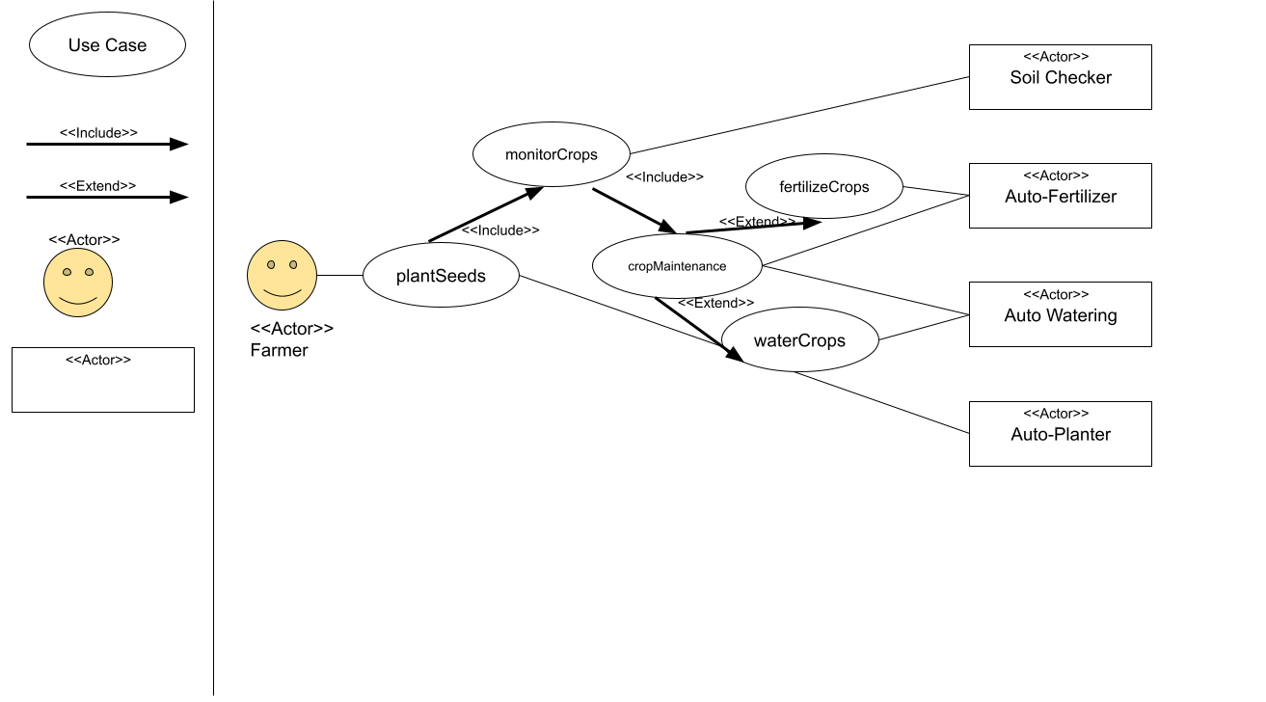

Livestock wellbeing and management: 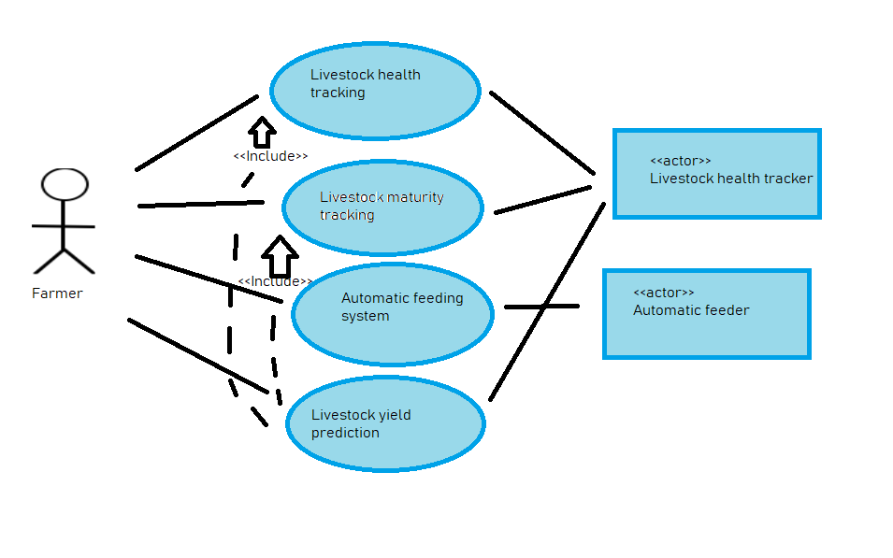

Harvesting and Harvest Management:

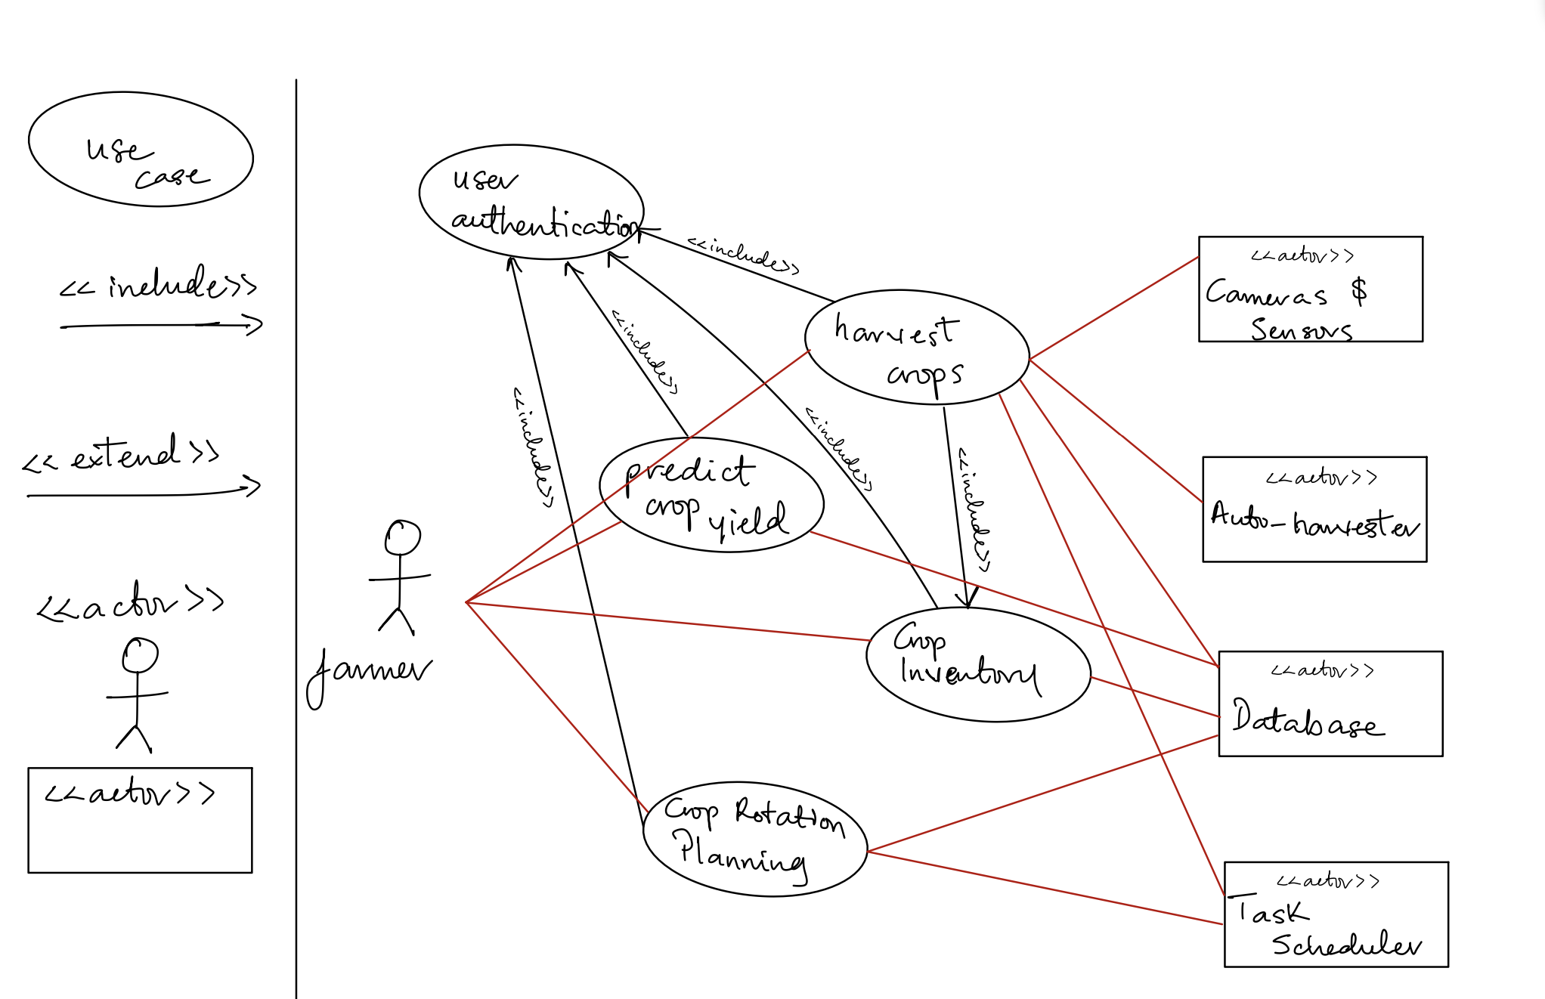

**Tools and Equipment**

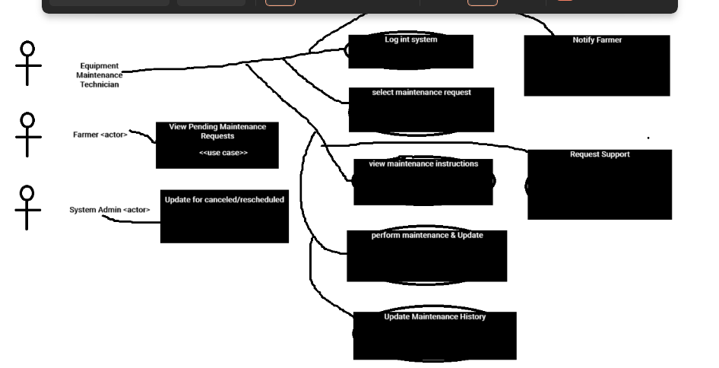

Sensors and Data Analysis Tools

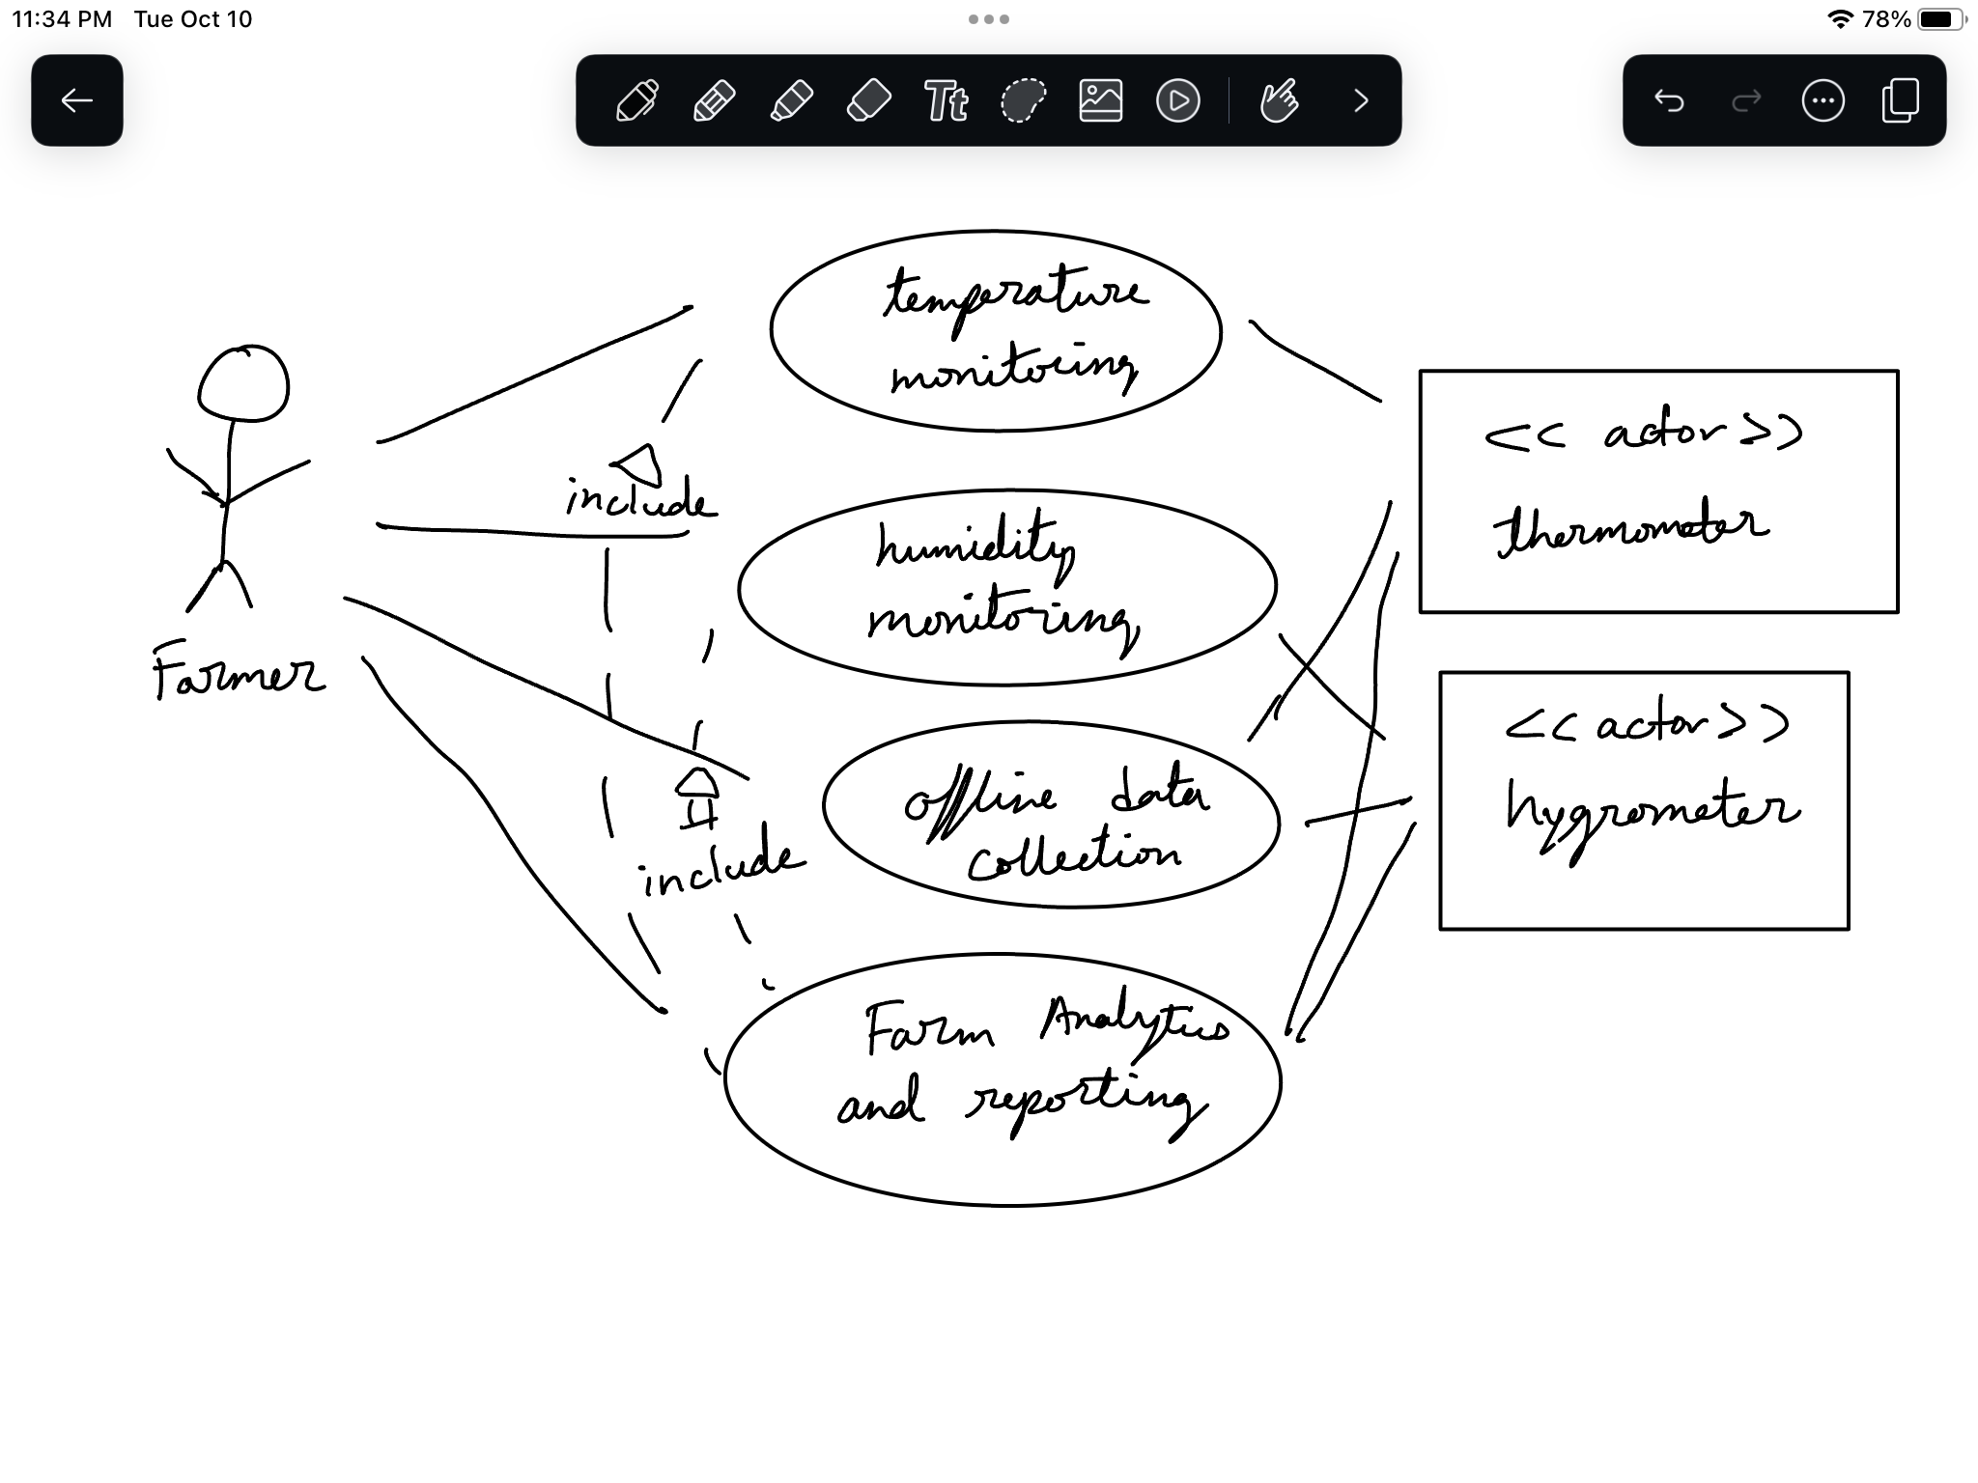

**Conceptual Class Diagrams**

External Factors:

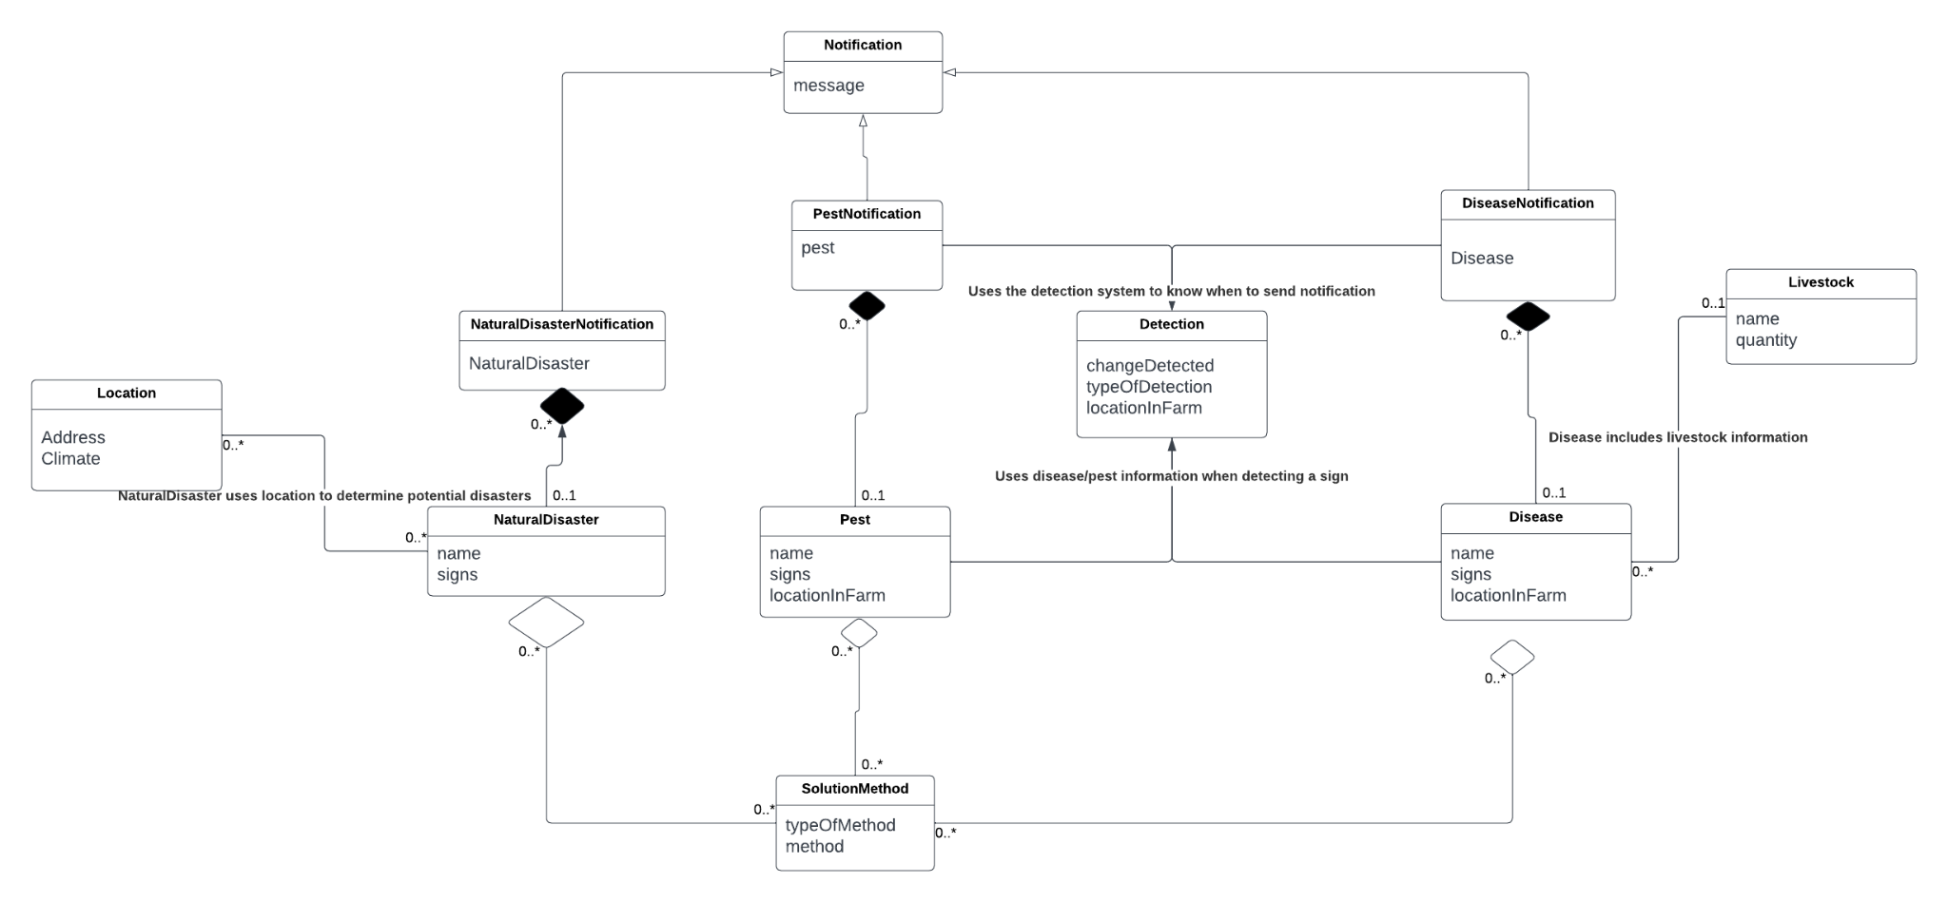

Soil Maintenance:

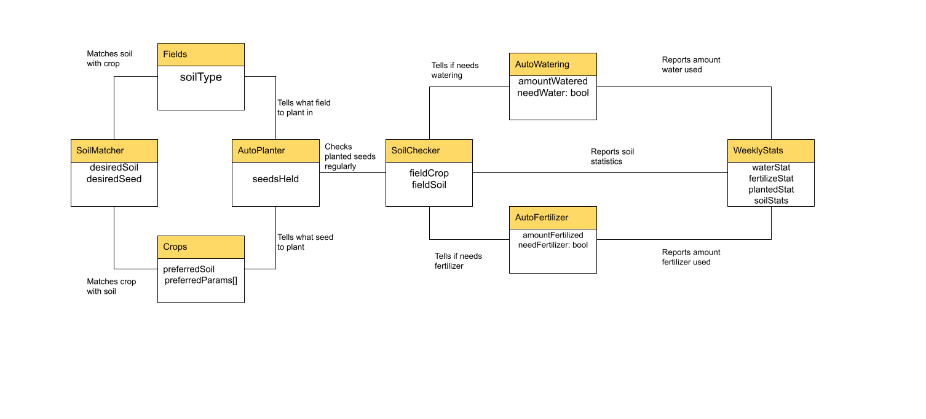

Livestock wellbeing and management: 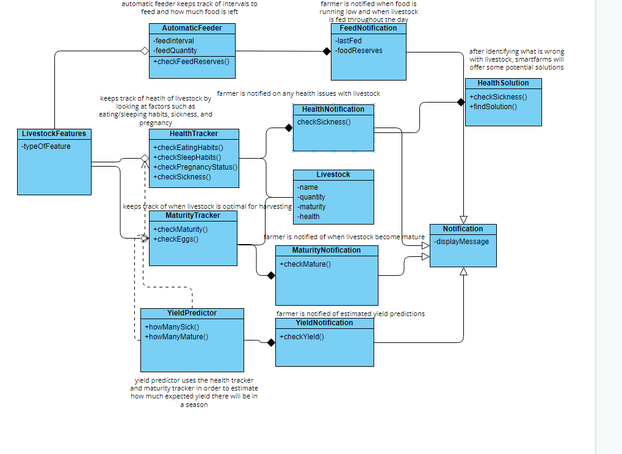

Sensors and Data Analysis Tools

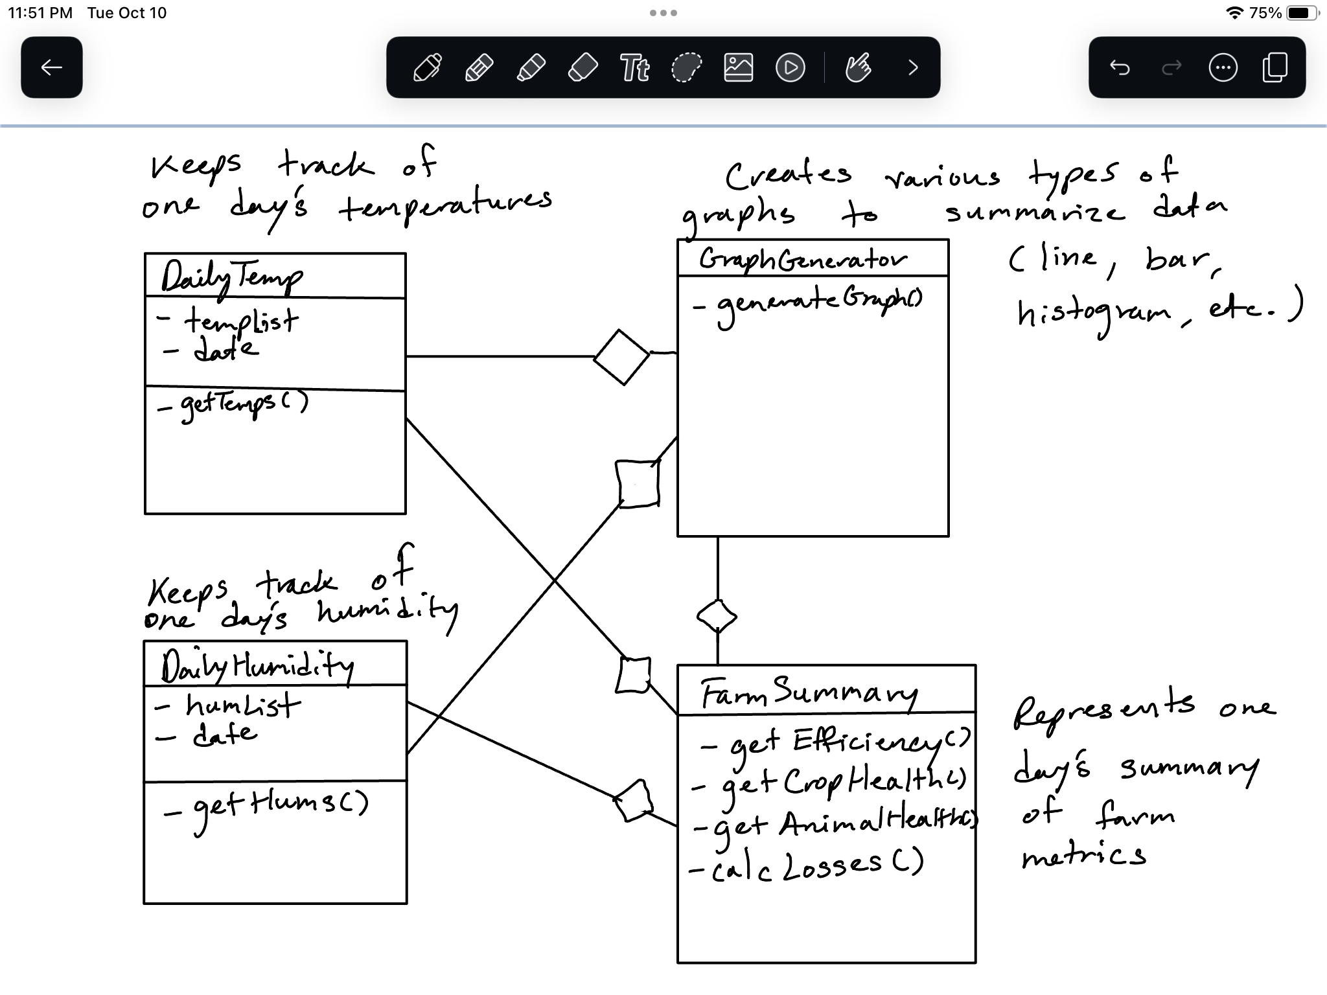

Harvesting and Harvest Management: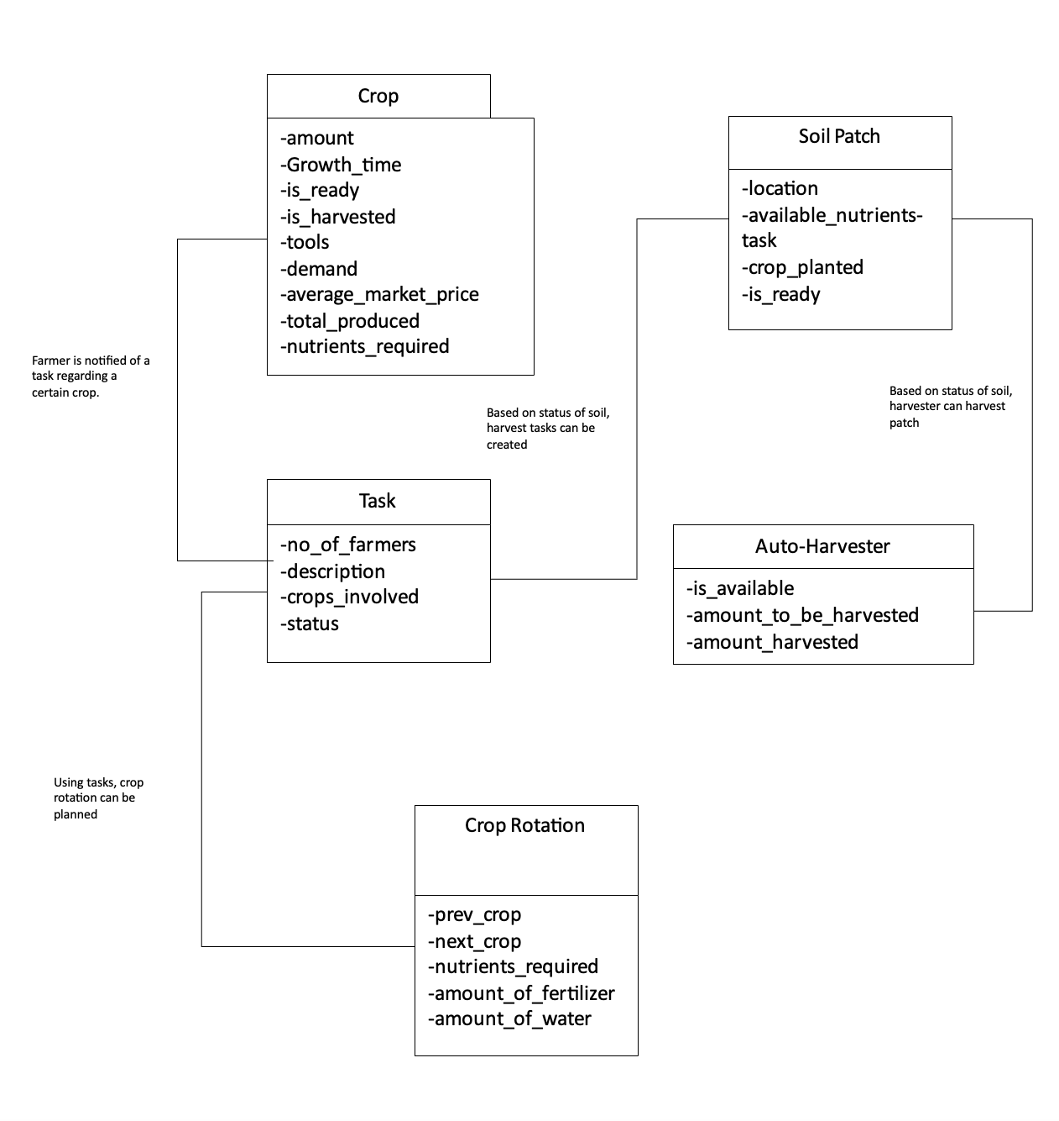

**Tools and Diagram:**

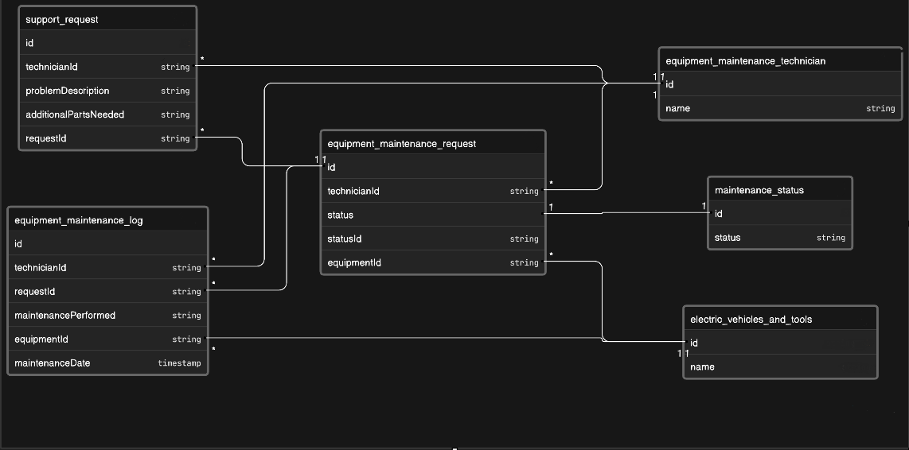

**Supplementary Specifications**

Scalability:

* The system must be able to accommodate a wide variety of farm sizes.
* Whether the farm is big or small, contain many livestock/crops or contains very little produce, the system must be able to maintain operations regardless of size
* The system also must be able to scale to add new features. Changes to databases that provide information to users are unavoidable, so the system must be able to handle increasing amounts of data. In addition to that, new technologies may be introduced to farms, which the system must incorporate gracefully.
* Individual farms themselves are subject to size changes. Therefore, on an individual basis, the system must be able to accommodate any changes made to each farm and each user.

Compatibility:

* The farm must be compatible with all soils and crops used and be able to provide appropriate amounts of water and fertilizer to them
* Soil maintenance should be able to work year round in a variety of climates, taking into account rainy seasons or drought conditions.
* Must be able to adjust to unexpected weather conditions either automatically or when prompted by operator

Usability:

* The system needs to accomodate to people with differing levels of familiarity with technology
* Whether or not someone uses technology often, SmartFarms should be easy to use, well organized, have good formatting, and provide user support
* SmartFarms will offer user support through a FAQ section, live agent support, and provide useful error messages to help the user
* In addition, SmartFarms will also offer mobile support, helping farmers to access their farm information even when they aren’t home
* Mobile support will give farmers fast and convenient access while on the go

Availability:

* System must be available for use 24/7
* System must minimize downtime (when retrieving data from DB, making calculations)
* System will have powersaver. Collect data from sensors in buffer while system is not in use. Reduced data collection frequency. Then upload data to DB when system is active.
* Catching exceptions and handling errors (e.g., broken/disrupted sensors) will be done by externally system to allow system to still function properly. System errors and exceptions will be logged and presented to user.

Performance:

* System must be running on up to date hardware and utilize a strong wireless connection for fast response times for real-time data and alerts
* The system backend must include optimized DB queries and writes so that the application and hardware does not become bogged down
* The application must go through load testing to ensure the system can handle peak concurrent usage

Data Encryption

* Encrypt all smart farm data to ensure confidentiality and integrity.
* Utilize robust encryption algorithms for strong security.
* Maintain a secure key management system to safeguard encryption and decryption keys.
* Restrict data access to authorized personnel via access controls and role-based permissions.
* Implement integrity checks to identify tampering or data corruption.
* Log key events related to data encryption for auditing and security incident monitoring.
* Regularly review and audit encryption mechanisms for accuracy and effectiveness.
* Comply with data protection regulations and industry standards to secure smart farm data.